L-1 Sketch | L-2 Sketch | L-3 Sketch
 | 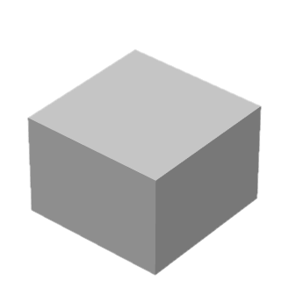 | 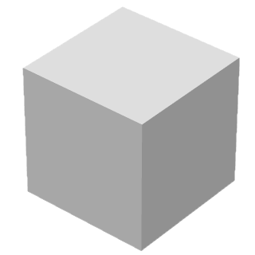
L-4 Sketch | L-5 Sketch | L-6 Sketch

